МИНИСТЕРСТВО ОБРАЗОВАНИЯ И НАУКИ
РОССИЙСКОЙ ФЕДЕРАЦИИ
ПЕНЗЕНСКИЙ ГОСУДАРСТВЕННЫЙ УНИВЕРСИТЕТ

Историко-филологический факультет | Кафедра «Перевод и переводоведение»

Направление подготовки:  45.03.02 Лингвистика  Профиль подготовки:  Перевод и переводоведение | УТВЕРЖДАЮ:  Зав. кафедрой________________  «___»________________ 2016 г.

ЗАДАНИЕ
на курсовую работу по дисциплине «История и культура стран изучаемого языка»

Тема: «Достопримечательности Ирландии»

Перечень подлежащих разработке вопросов:

1. Основные достопримечательности Ирландии
2. Замки Ирландии
3. Водопады Ирландии

Руководитель работы,
к. пед. н., доцент Х.Ж. Хайрова

График выполнения курсовой работы
№ п/п | Вид деятельности | Срок выполнения раздела | Подпись руководителя | Подпись зав. кафедрой
1 | Выбор, обоснование и утверждение темы курсовой работы;  составление плана курсовой работы;  формирование корпуса источников и литературы | 04.09 – 29.09
2 | Написание и сдача на проверку введения и 1 главы (раздела) курсовой работы | 02.10 – 01.11
 | Текущая аттестация по 1 к.т. | 01.11.16
3 | Написание и сдача на проверку 2, n... главы (раздела), заключения, оформление библиографического списка курсовой работы | 02.11 – 14.12
4 | Представление завершенной работы | 15.12.16
 | Текущая аттестация по 2 к.т. | 15.12.16

6. Дата выдачи задания «29» сентября 2016 г.

Руководитель к/р ___________________________________________
^{(подпись)} ^{(ФИО)}

Задание принял к исполнению студент ________________________________
^{(подпись)} ^{(ФИО)}

МИНИСТЕРСТВО ОБРАЗОВАНИЯ И НАУКИ РОССИЙСКОЙ ФЕДЕРАЦИИ
ПЕНЗЕНСКИЙ ГОСУДАРСТВЕННЫЙ УНИВЕРСИТЕТ
Кафедра «Перевод и переводоведение»

Курсовая работа
по дисциплине «История и Культура Стран Изучаемого Языка»
на тему «Достопримечательности Ирландии»
ПГУ 1.114040062.04.001

Направление подготовки – 45.03.02 Лингвистика
Профиль подготовки – Перевод и переводоведение

Выполнил студент: _______ Кочеткова И.В
Группа: 15ИЛ1

Руководитель:_________ Хайрова Х.Ж
к.пед.н., доцент

Работа защищена с оценкой ___________
Преподаватели ___________ ____________ ____________
Дата защиты ___________
2016
Contents
Introduction 2
1. Sights of Ireland 3
1.1 The Giant’s Causeway 3
1.2 Skellig Islands 4
1.3 Glendalough 4
1.4 Monastic City 5
1.5 The lower and upper lake 6
1.7 Habitat and Wildlife at the Glenveagh 7
1.8 The Glenveagh Castle 8
1.9 The Ring of Kerry 9
1.10 Trinity College Dublin 10
1.11 St.Patrick's Cathedral 10
2. Castles 11
2.1 Kilkenny Castle 11
2.2 The Rock of Cashel 12
2.3 The Malahide Castle 12
2.4 Blarney Castle 12
2.5 Trim Castle 13
3. Waterfalls 13
3.1 Ireland’s Highest Waterfall 13
3.2 Glencar Waterfall 14
3.3 Torc Waterfall 14
Conclusion 15
Appendix 17

Introduction
Ireland is an island on the west side of Europe. The capital of Ireland is Dublin. This is "the land of saints and scholars" and boasts more Nobel Prize winners for literature than any other country in the world. Dublin was designated a UNESCO City of Literature in 2010. There are about 5 million people in the Republic of Ireland. It is a small country but a lot of people know about it. In many countries there are Irish priests and nuns. The country is in two parts. The larger part, the Republic of Ireland, is in the south. The smaller part of Ireland, Northern Ireland, is part of the United Kingdom and its big city is Belfast. Like a lot of other countries, Ireland had sad and difficult times, but it had good times too. The Irish are kind and polite people, they welcome strangers. The Irish love to talk. Ireland is a beautiful country with fine lakes, tall mountains and attractive beaches. It has two great rivers. It is a very green country. It is green partly because it rains too much. Ireland is a country of good butter, good beer and good horses. People come from all over the world to buy Irish horses, from Europe, from America, from Arab countries and from the Far East. Ireland also has its manufacturing industry.

Sights of Ireland

The Giant’s Causeway
Northern Ireland’s only UNESCO World Heritage-listed site, the Giant’s Causeway is proof that Mother Nature provides the most dramatic tourist attractions. The natural wonder is comprised of around 40,000 polygonal basalt rock columns, formed by the ancient volcanic landscape and stretching along the coastline like a series of gigantic stepping stones. A Giants Causeway Day Trip from Belfast is one of the country’s most popular excursions, with visitors taking the unique opportunity to walk one of nature’s most peculiar pathways.Ireland’s mighty Cliffs of Moher reign strong as one of the country’s most visited natural attractions - towering 214 meters over the Atlantic Ocean in western Ireland. The iconic cliffs run from near the village of Doolin for around 8km to Hags Head in County Clare and host the country’s most spectacular coastal walk. Carved out by a gigantic river delta around 320 million years ago, the imposing cliffs also offer incredible views, stretching over Galway Bay, the distant Twelve Pins mountain range and the northern Maum Turk Mountains.[app.1]

Skellig Islands
Ireland’s magnificent UNESCO World Heritage Skellig Islands make a worthy side trip from the popular Ring of Kerry tourist trail, a pair of small rocky mounds that rise up from the sea off the coast of Portmagee. Not only are the two islands - Skellig Michael and Little Skellig - home to a fascinating 6th-century monastic complex perched on the 230-meter high cliff top, but they also host an impressive array of birdlife. Look out for Gannets, Black Guillemots, Cormorants, Razorbills and Herring Gulls as you climb the hair-raisingly steep 600-step climb to view the monastic remains. [app.2]

Glendalough
The name "Glendalough" means "the glen of two lakes" in the Irish language. The valley is located only around 50 kilometers (30 miles) from the Irish capital city - Dublin. It's very easily accessible, only one hour drive and it's a perfect place for a weekend or even one-day escape from the city crowds. The ruins of the ancient monastic city, two magnificent lakes surrounded by cliffs and rocks, nearby forests as well as waterfalls create an unforgettable scenery. There are many trails available for visitors in the area. Hiking one of them is not too difficult, there are many observation points that offer a spectacular view over the whole valley, lakes and the monastic city. [app.3]

Monastic City
The monastic city lies just beside the tourist information office and the Glendalough hotel. It was founded by Saint Kevin in the sixth century AD. This more than 1500 year-old medieval town contains a few churches, the cathedral, graveyards and the distinctive round tower that rises high up above the settlement. The area was rich in forests and fertile soils that provided crops for the inhabitants and gave the shelter for wild animals. The monks lived in full harmony with the nature. They used herbs for medicinal and culinary purposes, oak galls to make black inc and timber as fuel.The Gateway of Glendalough was connected to the defensive walls that surrounded the city. It is the only early medieval gateway preserved to this day in Ireland. You can still admire the beautiful arch of this granite construction. It used to have two stories and a wooden roof. In the upper part of the gate, there was probably a guard who was watching those approaching the city.The Round Tower was built between 900 and 1200 AD. It's around 30 meters (100 feet) high. It was used for calling the monks for prayers as well as for defense purposes. The main door is located 3.5 meter (12 feet) above the ground. It could only be reached by a ladder that in case of invasion was pulled into the tower preventing the invaders to get inside. There is also a smaller hole right above the ground but its purpose is unknown. On the top, there are four windows that were most probably used for observation of the area.The Cathedral dates back to the tenth century, however, later in the twelfth and thirteenth century some elements and decorations were added, for example the chancel and sacristy. It was dedicated to Saint Peter and Paul. It is the largest of all the churches in Glendalough and the largest early christian church in Ireland. the roof is destroyed but the beauty of the architecture including magnificent arches can still be admired. The floor is paved with gravestones, some of them dating back to the medieval times, some relatively new. Nearby, there is an early christian, medieval, typical to the region cross known as Saint Kevin's Cross.
Saint Kevin's Church known also as Saint Kevin's Kitchen (probably because of its small size) was built in the twelfth century. It is the only church on the site which is completely preserved and has a steep, stone roof. On the top of the church, there's a small round belfry with four windows.
The Reefert Church was built in the eleventh century. It's located a bit away from the main center of the settlement, near the Poulanass Waterfall. The information sign says that it was the burial place of the local chieftain's clan - O'Tools. In the surroundings of the church there is a number of early christian gravestones and crosses.
The Deer Stone is an example of a bullaun stone (from Irish: bullan) meaning a bawl. It's a flat stone with a hole in it that resembles a vessel. The exact purpose of the deer stone in Glendalough is not known, it might have been use for spiritual or religious rites or for grinding the grains. What's interesting is the story behind it. According to the legend, the wife of one of the Saint Kevin's workers died while giving birth to their twins. The worker asked Saint Kevin for help. After Saint Kevin's prayers, a doe came from the woods every morning and left milk for the workman in the hole of the stone. This way he was able to feed his children. The deer stone was also a pilgrimage station for Christians in Ireland.

The lower and upper lake
From the monastic city, the trail will pass by the lower lake which is quite small and not very spectacular. Much smaller than one of the main attractions of Glendalough, the upper lake. After fifteen minutes walk you should go around the lower lake and reach the upper one. There are some fast food facilities, toilets and also a car park there. There's a lot of space for picnics so it's a perfect place for the families. At the lake, there's a little beach but swimming is not allowed because of underwater cliffs. The color of water is brown and resembles coca cola.This is caused by the rainwater that runs through peat-rich soils and flows down the cliffs into the lakes. The upper lake looks truly magnificent surrounded by the rocky hills and mountains that were formed by the glaciers during the Ice Age.
1.6 The Glenveagh National Park
Great mountains looming towards the horizon with freshwater lakes gracing the bottom; varied wildlife inhabiting pristine woodlands, and all rounded off by a secluded medieval style castle — a trip to the Glenveagh National Park in Ireland is almost like stepping into the world of a dream. Glenveagh National Park is one of the major eco-destinations in Ireland. Thousands visit it all the year round for a close encounter with nature at its purest.

1.7 Habitat and Wildlife at the Glenveagh
The entire territory of the Glenveagh National Park can be divided into at least four different habitats, which include hilltops, bogland, woodlands and freshwater. Each has its unique range of flora and fauna. The hilltop region of Glenveagh National Park has Alpine and semi-Alpine habitat. Most of the plants are lie low and close to the ground. The mountain hare, kestrel and ravens are some of the animals you can expect to spot in this part of the national park.
The bogland was once home to pine and birch trees that extended right to the foot of the uplands. However, over the years, it has shrunk much and now only a small fragment of its original vegetation remains. The habitat is typically western or Atlantic type, and some of the plants that can be found in the drier patches include crowberry, blueberry, bell heather and ling heather. The bog is also home to the red deer, the largest specie of the park. The rare meadow pipit birds can also be found in this region. The woodland region covers about 100 hectares. Most of the woodland is natural, though there is a small portion of semi-natural woodland as well. Dominant plants include oak, birch, hazel, aspen, holly and rowan. It is a typical example of a western Oakwoods as found in Scotland, Wales and Ireland. The woodlands become a hub of activities during the summer time. The abundance of foliage attracts a large number of birds and insects as well as small animals. Badgers and foxes are found in this part of the park, but the most interesting animal is definitely the wood warbler with its typical call. Some typical pinewood birds like siskin, goldcrest and crossbill and coaltit are also found in the coniferous part of the woodland.
The lakes of the Lough Veagh are the main water providers to the park. The clear, highly oxygenated water is a great habitat for sea trouts, salmons and the arctic charr. The region is also an active breeding ground for waterfowls.

1.8 The Glenveagh Castle
The Glenveagh Castle is the most remarkable architectural piece in the garden. Built in accordance to the Victorian ideal of sublime seclusion, the castle is built in an anachronistic style like old Irish fort towers. Built almost completely out of granite, found in abundance in this area, the castle has a no-frills and solid look, which belies its lavish interior. John George Adair, the first owner of the castle built it with the help of his cousin and friend, architect John Townsend Trech.
The interior of the Glenveagh Castle is just the opposite of its stark and daunting exterior. Equipped with all forms of luxury imaginable and tastefully built in style absolutely individual and eclectic, all rooms in the Glenveagh Castle is worth a visit. The eclectic and refined tastes of Henry McIlhenny, owner of the castle and former curator of Decorative Arts with the Museum of Philadelphia are expressed in every nook of the castle. It also acts as a landmark around which most walks in the park are planned and organized. Only guided tours are allowed inside the castle, and it takes about 30 minutes to complete the entire tour.
The Glenveagh Gardens is one of the greatest attractions of the park. This is a sprawling Irish style garden set amidst natural landscapes. Along with the indigenous plants that are found in the region, there is a wide collection of exotic plant species collected from all across the globe, including Tasmania, China and South America. The owners of the castle, including Cornelia Adair, the wife of the first owner of the park and McIhenny contributed significantly to the development of this garden, which has now developed as the most impressive and varied garden space in the whole of Ireland.

1.9 The Ring of Kerry
For many people around the world, the Ring of Kerry drive encapsulates their image of Ireland: ancient monuments, romantic castles, spectacular gardens and colorful towns and villages. The stunning scenery, dramatic coastline, charming locales and ancient archaeological treasures have been featured in postcards, film, poetry and song.Here, the idealized view of Ireland as a land of rural greenery and natural beauty springs to reality. Tourists come to Kerry to experience this rare dip into a lifestyle foreign in pace, philosophy and spirit. Each twist and turn on a drive around the Ring of Kerry reveals new sights - windswept cliffs, breathtaking scenery, spectacular lakes, rich flora and fauna, green and yellow checkered hills and unspoilt beaches.There is evidence of the region's unique heritage and culture everywhere, in the place names, the standing stones and the many archaeological sites. The 6th century beehive huts and ruined monastery on Skellig Michael are a UNESCO World Heritage Site. Also worth checking out are the stone forts at Caherciveen and Castlecove, the Neolithic stone circle in Kenmare, the 15th century Ballycarberry Castle, the magnificent O'Connell Memorial Church, Derrynane House and Gardens or the pretty 19th century Heritage town, Kenmare.
The Ring of Kerry is also highly regarded for it culinary delights, such as the local cheeses, seafood and shellfish, lamb and homemade breads. The town of Kenmare, in particular, has a number of very highly regarded restaurants. (It is thought to be the only town in Ireland that has more restaurants than pubs.)
The area is a favorite among artists, writers and sculptors, and there are a number of craft shops and galleries such as Cill Rialaig showcasing their best works. It's also ideal for activity holidays, such as walking and cycling routes, diving and angling and adventures sports, to its array of championship golf courses - Waterville (An Coireán), Dooks, Kenmare and Killorglin.The coastal roads provide an ever-changing landscape around the Iveragh Peninsula, with snapshots of the famous offshore islands popping in and out of view around every corner. [app.4]

1.10 Trinity College Dublin
Trinity College is Ireland's most prestigious college - and although its rivals at University College Dublin might dispute this, it's probably the best university in Ireland.But one thing not up for argument is the magnificent setting of Trinity: many of its majestic buildings are hundreds of years old. (The college was founded by England's Queen Elizabeth 1 in 1592.) Architecturally at least, Trinity is way above its nearest rivals.Although the college is best known for the Book of Kells, it's also worth going there to check out the Long Room of its old library. (Apparently, this room was the inspiration for a room called the Jedi Archives, in the movie, “Star Wars Episode II: Attack of the Clones.”).It is also worth taking one of the guided tours around the college as nearly every building seems to have an interesting story. Many of the tour guides appear to be Trinity College drama school graduates: They always seem to add a little dramatic flair to their tours.The best time of the year to visit this university is around the end of May, just after the students' exams are over. Then the whole college comes to life.A popular activity among its students is to sit out outside the Pavilion Bar (known as "The Pav"), while watching a game of cricket. [app.5]

1.11 St.Patrick's Cathedral
St. Patrick's Cathedral, Ireland’s largest church, is also one of the biggest tourist attractions in Dublin.In a well close to the cathedral, St Patrick was believed to have baptized converts from paganism to Christianity. To commemorate his visit, a small wooden church was built on the site. Later, in 1191, the present building was constructed, and St. Patrick's was raised to the status of a cathedral.
St Patrick's is also notable for being the first place where Handel's “Messiah” was performed, in 1742. Another interesting fact: Jonathan Swift, the author of “Gulliver’s Travels,” who was the dean of the cathedral from 1713-45, is buried here.While this cathedral is replete with history, St. Patrick's is not, however, a museum. It's still very much a living building with services held every day of the year. There are also sung services six days a week. The choir sings two services every day during school terms - the only cathedral in Ireland or Britain to do so. [app.6]

Castles
Ireland is a country of castles.

2.1 Kilkenny Castle
This is a wonderful castle and it is in absolute perfect shape including the surrounding walls and the castle proper. Although, it is kind of like those transitional castles that were fortresses transformed into elaborate manor houses. It maintains characteristics of both.And one of the special things about this castle is the city it is situated in, Kilkenny. It is a beautiful medieval town. And they often have arts festivals there. I just happened to be there while a festival was going on.Kilkenny Castle dates back to the 13th century and it was privately owned by the Butler family until 1967 when ownership was transferred to the country. And the roots of this castle actually go back to 1172 when Strongbow built a wooden fort on the location. Today it is more of a 17th century chateau. [app.7]

2.2 The Rock of Cashel
By all the tour and travel books of Ireland this castle is almost always listed as the number one castle to visit. It is pretty cool and pretty impressive. It sits on the top of a very steep hill which is of course an excellent place to put a fortress. This makes it very difficult to attack and very easy to defend. It is a limestone outcropping that reaches up about 200 feet. And this ruins is pretty old, dating back at least to around the 4th century. It served as a fortress right up to the 11th century. In 1101 it was given over to the church and became more of a monastery and ecclesiastical center. [app.8]

2.3 The Malahide Castle
A treasured castle that highlights the beauty of Dublin is the Malahide Castle. The castle lies on an area of about 250 acres, in the picturesque seaside of the Malahide town. The castle was used as a fortress and as a private house for over 800 years. The Malahide Castle is one of the oldest splendid castles of Ireland. It was the ideal home for the Talbot Family, for a period between 1185 to 1975. Then it was transformed into a notable tenure of a very famous family, which made the castle a remarkable treasure for Ireland.

2.4 Blarney Castle
The famous Blarney Castle in Ireland was built in 1446. Over the years, it has become a world landmark and one of Ireland’s most popular attractions. Many travelers believe that a trip to the medieval Blarney Castle can’t be missed; it’s on par with the Guinness Brewery and other attractions as an intrinsic symbol of Ireland and Irish heritage. It is located in Blarney Village, about 8 km northwest from Cork City in the southern Ireland.
The Blarney Stone is without a doubt the most famous part of Blarney Castle. Also called the legendary Stone of Eloquence, it is located at the top of the castle’s tower. Legend has it that if you kiss it, you’ll be struck with eternal eloquence and you will never be at a loss for words. [app.9]

2.5 Trim Castle
Trim Castle is a stunning Norman castle on the south bank of the River Boyne in Trim, County Meath. The largest Anglo-Norman castle in Ireland, it was constructed in Trim over a thirty-year period by Hugh de Lacy and his son Walter. Hugh de Lacy was granted the liberty of Meath by King Henry II in 1172 in an attempt to curb the expansionist policies of Richard de Clare (Strongbow).
Construction of the massive three storied keep, the central stronghold of the castle, was begun circa 1176 on the site of an earlier wooden fortress. This massive twenty sided tower, which is cruciform in shape, was protected by a ditch, curtain wall and moat. [app.10]

Waterfalls
Besides, Ireland is also famous for waterfalls

3.1 Ireland’s Highest Waterfall
Powerscourt Waterfall is Ireland’s highest at 121m (398ft.) and is 6km from the Main Estate. It is set in one of Ireland’s most beautiful parklands at the foothills of the Wicklow Mountains.As you drive from the gatelodge towards the Waterfall you are surrounded by Beech, Oak, Larch and Pine trees some of which were planted over 200 years ago. Look out for the Giant Redwoods, which are native to Northern California where they may grow up to 80m high and live for 4,000 years so they are still youngsters!The Waterfall is an ideal location for summer picnics and barbecues. There is a vast amount of space to keep children entertained. There is also a playground for younger children. But be mindful of the other inhabitants of the parkland! It is a haven for wildlife and children can have fun trying to spot some of the locals – the Chaffinch, Cuckoo, Raven and the Willow Warbler. Some other inhabitants are the Sika Deer which were introduced to Ireland in 1858 and there may be a red squirrel or two. [app.11]

3.2 Glencar Waterfall
Glencar Waterfall is a stunning cascade tumbling over the rocky cliffs on the edge of County Leitrim. Extending from the sharp ridge of Ben Bulben, the cliffs drop away into the deep lake of Glencar Lough. The falls are particularly stunning after heavy rains. Admire the stunning waterfall on an invigorating walk along wooded paths and trails through the Dartry Mountains. Wander along the Lake Shore Walk to admire the tranquil scene of Glencar Lough, a long lake straddling the border of counties Sligo and Leitrim. This gentle stroll offer Glencar Waterfall is 9 miles (14 kilometers) west of Manorhamilton and 8 miles (13 kilometers) northeast of Sligo town. The falls have a small information kiosk, picnic facilities and free parking lot. The falls have free entry and year-round access. Wear sturdy shoes and appropriate clothing for the walk. Bring a bottle of water, especially if you take the rather strenuous Bog Road trail.s a special insight into the bird life and ecology of the lake’s waters and surrounding wetlands. [app.12]

3.3 Torc Waterfall
A convenient place to start your exploration of Ireland's oldest national park, Torc Waterfall offers panoramic views of the region's three interlinked lakes. You can reach the base of the waterfall via a short trail through a densely wooded area, covered in moss and known for attracting herds of native red deer. This waterfall is an important natural landmark on one of the country's major long-distance walks, a 214 km (133 mi) long circular trail that begins and ends in the nearby town of Killarney. [app.13]

Conclusion
In fact,I knew a lot of new information about this wonderful island.
Welcoming and wonderfully rich in culture, Ireland, the "Emerald island," put a sparkle in my eye.
There are many places to visit in Ireland. It is a country that has a lot to offer to its visitors – from the stunning unspoilt nature and dramatic coastline to bustling cities and traces of the ancient past.
References
1.http://infocenter.ie/20-neveroyatno-krasivyh-mest-irlandii/
2.http://www.irishcentral.com/travel/best-of-ireland/irishcentrals-top-10-sites-in-ireland-41098302-237788301
3. https://www.inspirock.com/ireland/killarney/torc-waterfall-a88216627
4. https://top10.travel/dostoprimechatelnosti-irlandii/
5.https://www.expedia.com/Glencar-Waterfall-Glencar.d6086045.Vacation-Attraction
6. http://www.planetware.com/tourist-attractions/ireland-irl.htm
7. http://www.hoteltravel.com/ireland/guides/sightseeing.htm
8. http://www.traveltipy.com/places-to-visit-in-ireland-cities-towns/
9. http://www.huffingtonpost.com/viator/10-of-the-most-beautiful_b_4066929.html

Appendix
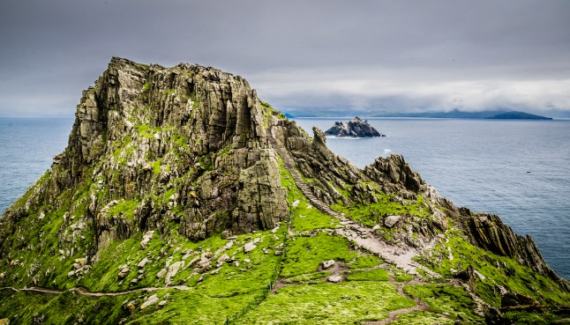
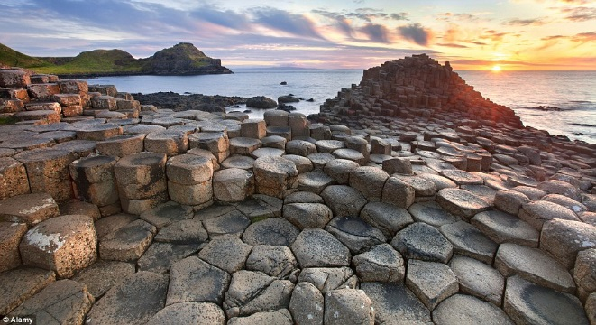
2 Skelling Islands
1 The Giant's Causeway
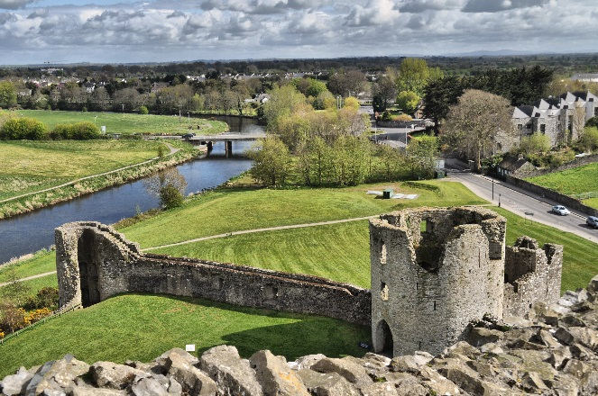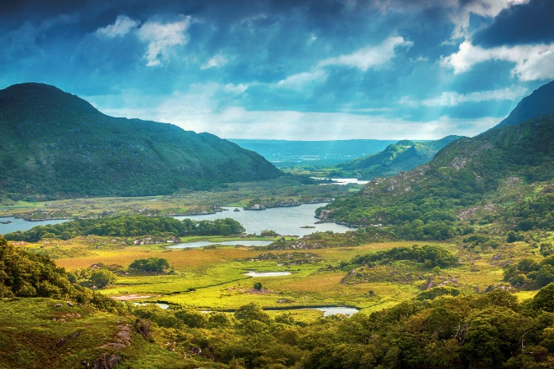
3 Glendalough 4 The Ring of Kerry
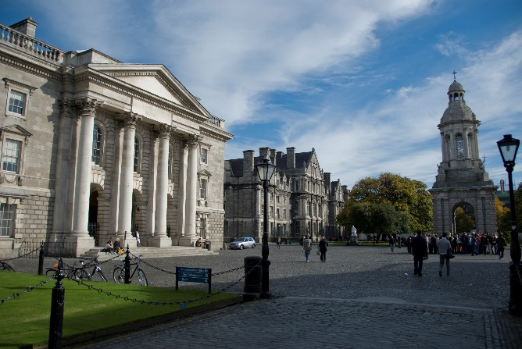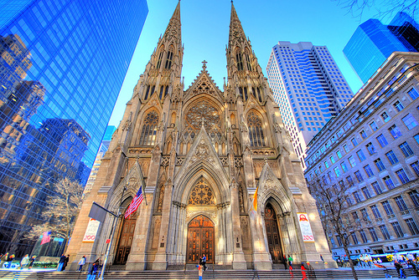
5 Trinity College Dublin 6 St.Patric's Cathedral
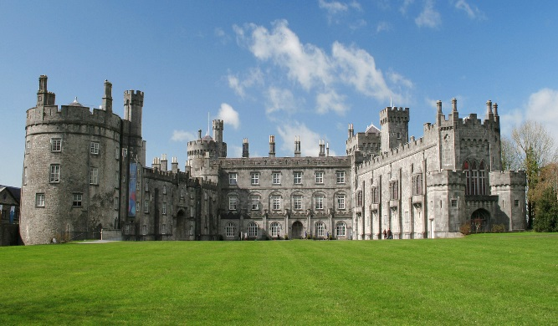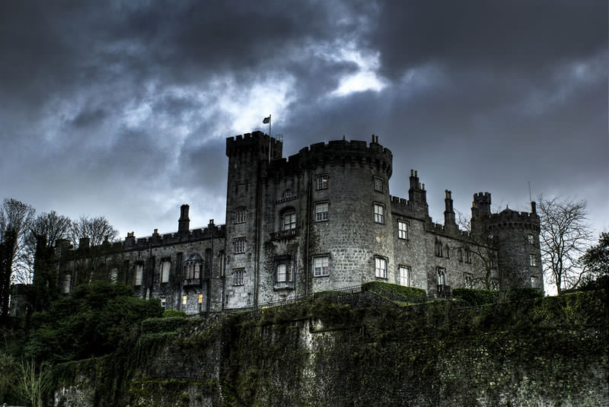
7 Kilkenny Castle
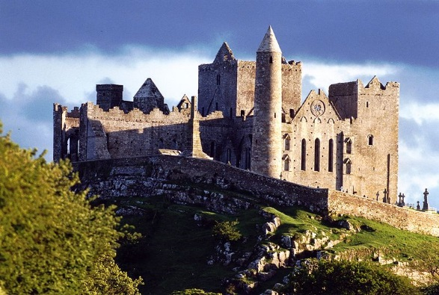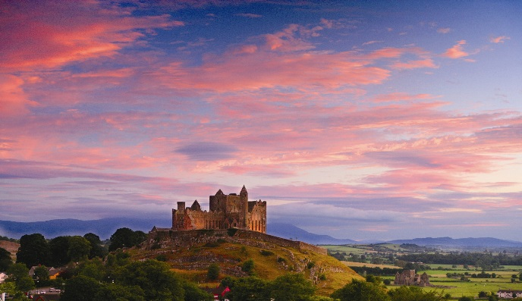
8 The Rock of Cashel
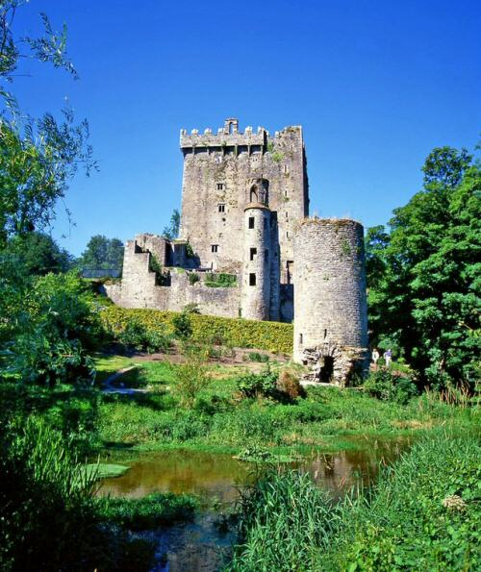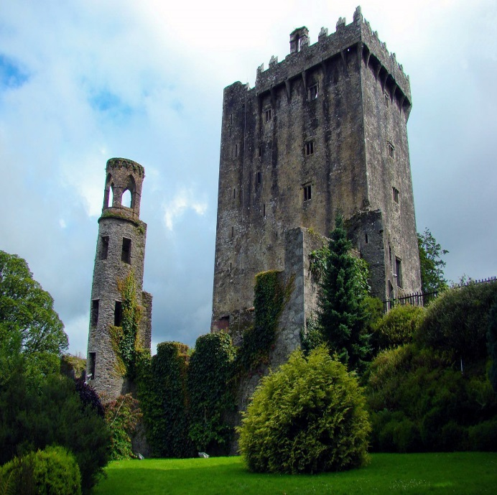
9 Blarney Castle
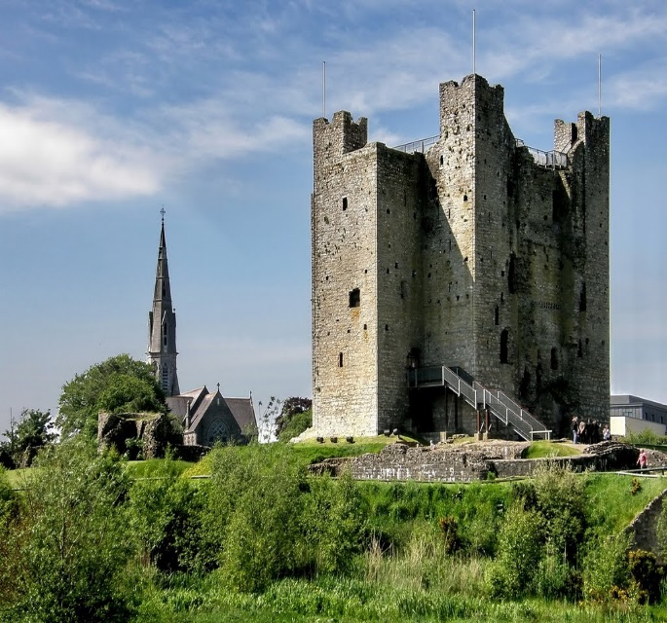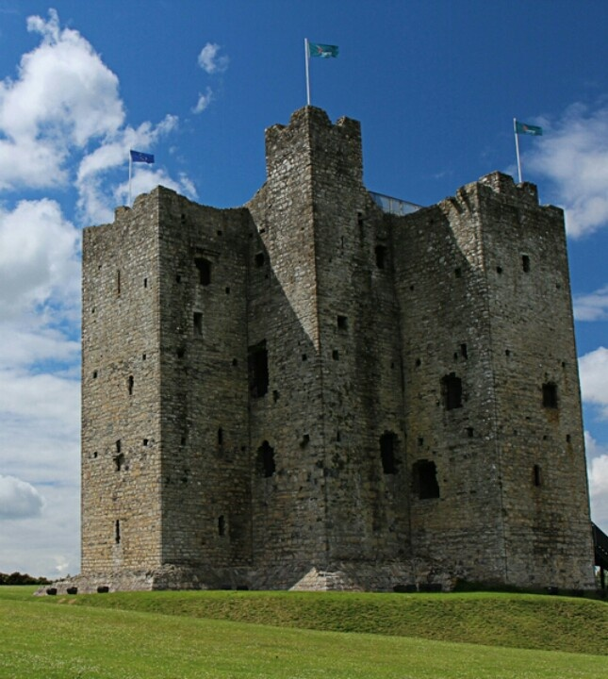
10 Trim Castle
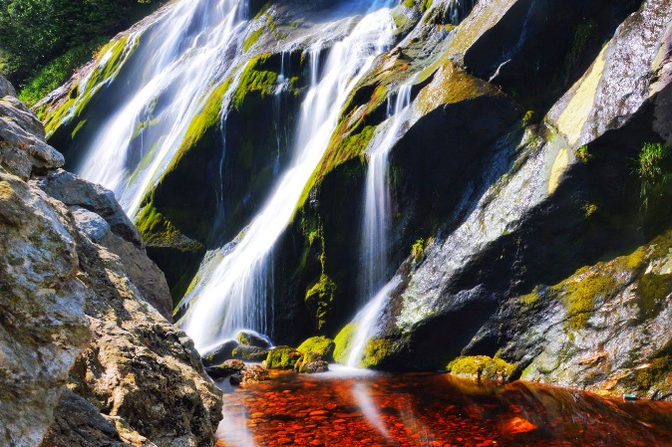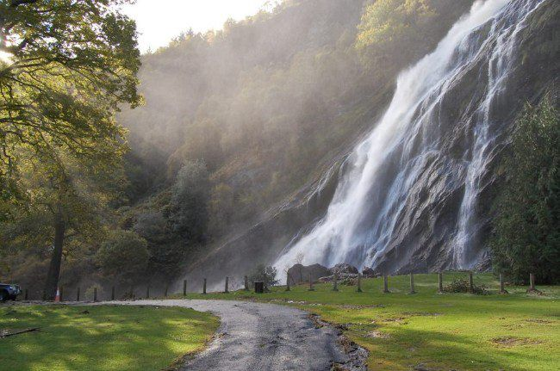
11 Ireland's Highest Waterfall
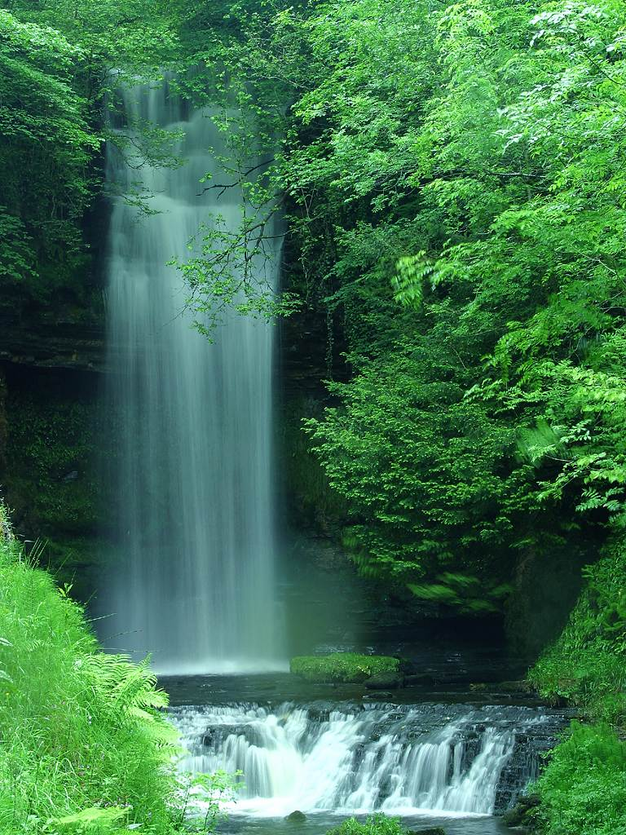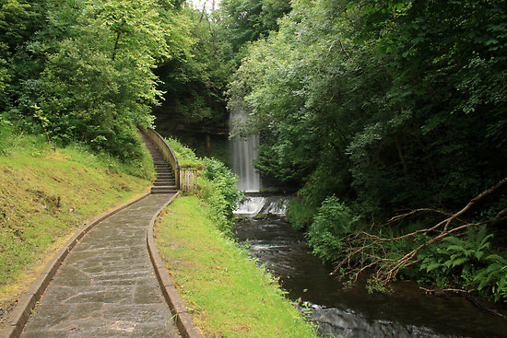
12 Glencar Waterfall
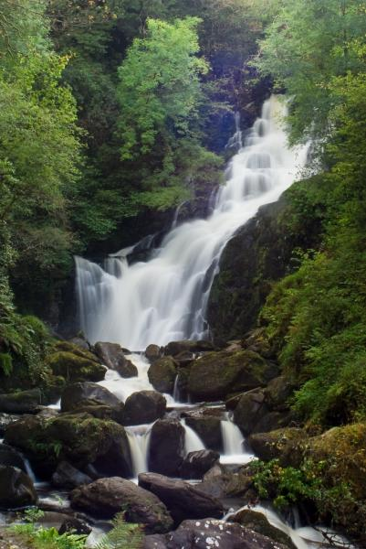
13 Tork Waterfall

