Penza State University
Department of Computer Engineering

EXPLANATORY NOTE
For the course Cross Platform Application Development
Implementation of the Space Shooter Game in Java
A desktop application with interacting classes and a graphical interface
Completed by student of group 23ВВИм1:
Mohamed Fikri
Accepted by:
Ph.D., Associate Professor O.V. Yurova
Penza 2026

PENZA STATE UNIVERSITY
Faculty of Computer Engineering
Department of Computer Engineering
APPROVED
Acting Head of the CT Department
Ph.D. N.S. Karamysheva
____________________ 2026
ASSIGNMENT
for coursework in Cross Platform Application Development
Student: Mohamed Fikri Group: 23ВВИм1
Project topic: Development of the Space Shooter desktop game in Java

Initial data and technical requirements
Develop a two dimensional arcade game in which the player moves a spaceship, fires bullets and prevents enemies from reaching the bottom of the playing field. Use Java and the NetBeans development environment. Implement a graphical interface, collision detection, score calculation, a lives counter, successive enemy waves and restart after game over.
The application is organized into five interacting classes: SpaceShooter, GamePanel, Player, Enemy and Bullet. It uses the Java Collections Framework, exception handling and Java multithreading. The course sample also requires the Java Stream API; this requirement remains outstanding in the current implementation.

Functional requirements
No | Requirement | Implementation
1 | Display an 800 by 600 pixel playing field | Swing JPanel and AWT graphics
2 | Move and shoot using the keyboard | Left arrow, Right arrow and Space
3 | Manage enemies and projectiles | List collections backed by ArrayList
4 | Track progress and losses | Score, lives, wave and remaining enemies
5 | Restart an ended game | R key resets the game state

Scope of work for the course

Computational part
Define the game state and object coordinates. Implement keyboard driven ship movement, projectile motion, enemy spawning, rectangular collision tests, score updates, life loss, wave completion and restoration of the initial state. Explain the update cycle and the cooperation of the five program classes.

Graphical part
Prepare UML use case, class, activity, sequence and deployment diagrams. Illustrate the initial playing field, an active game state and the game over screen. The five UML diagrams are presented in Appendix B.

Experimental part
Compile the source and check movement, screen boundaries, bullet creation and removal, spawning limits, collisions, life loss, wave changes, game over, restart and thread interruption. Record the environment, conditions and results of the checks.

Project execution schedule by sections
Stage | Work | Deliverable
1 | Analyse the task and gameplay rules | Problem statement
2 | Select tools and define the architecture | Technical specification
3 | Implement the window and game objects | Five Java classes
4 | Implement the game loop and interactions | Playable game logic
5 | Check behaviour and review limitations | Validation results
6 | Prepare illustrations and UML diagrams | Graphical documentation
7 | Prepare the explanatory note and defence | Completed report

Assignment issue date: ____________________ 2026
Project defence date: ____________________ 2026
Supervisor: O.V. Yurova
Assignment received: ____________________ 2026
Student signature: ____________________

Table of Contents
Introduction 5
1 Problem Statement 6
2 Solution Selection 7
2.1 Development Environment 7
2.2 Technical Specification 7
2.3 Course Technologies 8
3 Program Description 9
3.1 SpaceShooter class 9
3.2 GamePanel class 9
3.3 Player class 10
3.4 Enemy class 10
3.5 Bullet class 10
3.6 Main Algorithms 11
3.7 Threading and Exception Handling 11
4 Description of Program Results 12
4.1 Launch and Controls 12
4.2 Gameplay and Score 13
4.3 Game Over and Restart 14
4.4 Validation Results 15
4.5 Limitations and Further Development 16
Conclusion 17
List of References 17
Appendix A Program Listing 18
A1 SpaceShooter source file 18
A2 GamePanel source file 19
A3 Player source file 26
A4 Enemy source file 28
A5 Bullet source file 29
Appendix B UML Diagrams 30
B1 UML Use Case Diagram 30
B2 UML Class Diagram 31
B3 UML Activity Diagram 32
B4 UML Sequence Diagram 33
B5 UML Deployment Diagram 34

Introduction
This coursework presents the design and implementation of Space Shooter, a desktop arcade game written in Java. The player controls a spaceship at the bottom of the window and fires at enemies descending from the top. The application maintains a score, a limited number of lives and a sequence of enemy waves. Its purpose is to demonstrate how separate classes cooperate within a graphical application and how a repeated update cycle connects input, simulation and rendering.
The project is a NetBeans Java application with an Ant build configuration. Its source belongs to the spaceshooter package and contains five classes: SpaceShooter, GamePanel, Player, Enemy and Bullet. SpaceShooter creates the application window. GamePanel coordinates the simulation and drawing, while the remaining classes represent the objects that move and interact in the playing field. This division keeps object behaviour separate from the overall rules of the game.
Swing supplies the window and panel, and AWT supplies drawing operations, keyboard events and rectangular collision checks. The objects are drawn using geometric shapes, so the application does not require image files, sound files, a network service or a database. Lists hold the changing sets of bullets and enemies. A dedicated thread performs game updates and requests repaints, while interruption handling provides a controlled exit from the update loop.
The report explains the requirements, choice of tools, class responsibilities and algorithms. It then describes the user workflow and presents controlled validation results. Appendix A contains the program listing, and Appendix B contains the use case, class, activity, sequence and deployment diagrams. The implementation demonstrates collections, exception handling and multithreading; the Stream API requirement is identified separately because no stream pipeline is present in the source.

1 Problem Statement
The task is to develop a Java desktop game with a graphical interface and a structure divided into cooperating program classes. The application must accept keyboard input, display changing game objects and evaluate interactions between projectiles, enemies and the player. It must also maintain consistent statistics, progress through waves and allow the player to begin again after losing all lives.
The playing field is fixed at 800 by 600 pixels. The ship moves horizontally and must remain inside this field. Enemies appear at random horizontal coordinates and descend vertically. A bullet that hits an enemy removes both objects and awards ten points. An enemy that reaches the lower boundary or touches the ship costs one life. The game starts with three lives and stops updating gameplay when the lives counter reaches zero.
The first wave contains five enemies. Each subsequent wave contains two more enemies than the preceding wave. A wave is complete after every required enemy has appeared, all of those enemies have been handled and the enemy list has become empty. Handling includes shooting an enemy, colliding with it or allowing it to pass the bottom boundary. Only a bullet hit awards points.
The term multi module in the course assignment describes the separation of responsibilities across the program classes. The delivered project is one Java application in one package; it does not define separate Java Platform Module System modules, Maven modules or independent services. Its architectural units are the five classes and their interactions.

Course requirement coverage
Requirement | Evidence in the code | Status
Graphical interface | JFrame, JPanel and Graphics2D | Implemented
Collections Framework | List<Enemy>, List<Bullet>, ArrayList and removeIf | Implemented
Exception handling | InterruptedException catch in GamePanel.run | Implemented
Java multithreading | GamePanel implements Runnable and starts Thread | Implemented
Java Stream API | No stream() call or stream pipeline in the five classes | Outstanding

The controls and user interactions are shown in the UML use case diagram in Appendix B.1. The class structure is shown in Appendix B.2.

2 Solution Selection

2.1 Development Environment
The project uses Apache NetBeans and the standard Java libraries. NetBeans is a suitable environment for editing the source, selecting the Java platform, building the application and running its main class. The archive contains build.xml and the nbproject directory, which identify the project as a NetBeans application with an Ant based build. The configured main class is spaceshooter.SpaceShooter, and the distribution JAR is named SpaceShooter.jar. [1]
The project properties specify Java source and target level 26. A normal build with these settings therefore requires a compatible JDK, or an explicit change to the compiler levels and selected platform. The controlled checks described in Section 4.4 compiled the unchanged source separately with Java 17 using --release 17. This checks source compatibility with Java 17; it does not verify the original NetBeans build under JDK 26.
No third party library is listed in the project classpath. The implementation uses classes from java.base and java.desktop. This keeps deployment simple: the game runs locally on a computer with a compatible Java runtime and a graphical desktop. Cross platform suitability follows from the use of standard Java desktop APIs, although operating system specific execution was not evaluated in the controlled checks.

2.2 Technical Specification
Parameter | Value in the implementation
Playing field | 800 by 600 pixels; fixed size window
Initial player position | x = 375, y = 520
Player size and movement | 50 by 40 pixels; 6 pixels per update
Bullet size and movement | 5 by 15 pixels; 10 pixels upward per update
Enemy size and movement | 40 by 40 pixels; 3 pixels downward per update
Spawn interval | One enemy after each 60 eligible updates
Initial state | Score 0; lives 3; wave 1; five enemies required
Wave size | N(w) = 5 + 2(w - 1)
Score per successful hit | 10 points
Loop delay | Thread.sleep(16), in addition to processing time

The delay is a pacing mechanism rather than a fixed frame rate guarantee. Rendering is requested asynchronously, and the time taken by updates, painting and scheduling contributes to actual performance. Movement is measured per update, so a slower update cycle also slows the game.

2.3 Course Technologies
The Java Collections Framework is used in two places. GamePanel stores enemies through a List<Enemy> reference backed by an ArrayList. Player stores bullets through a List<Bullet> reference backed by another ArrayList. Objects are appended when they are spawned or fired. Enhanced for loops update and examine the objects, and removeIf removes entries whose active flag is false. [2]
The use of a lambda expression in removeIf does not constitute use of the Stream API. removeIf is a Collection operation, whereas a stream pipeline normally begins with a stream source and applies intermediate and terminal operations. There are no stream(), parallelStream() or java.util.stream calls in this project. If the assignment requires all four technologies, a meaningful stream based operation must be added before that requirement can be marked complete. [2, 3]
A possible future use is to calculate a read only statistic from a stable snapshot of active enemies, for example by applying filter and count to an enemy stream. This would demonstrate the API without replacing the sequential update loop. Such a change is a proposed extension and is not part of the program listing or the validation results in this report.
Multithreading is implemented by GamePanel through the Runnable interface. startGame creates a Thread and starts it once, provided the gameThread reference is null. The run method repeatedly calls update and repaint, then sleeps for sixteen milliseconds. Keyboard handling and Swing painting are associated with the event dispatch thread, while simulation updates are performed by the game thread.
Exception handling is applied to Thread.sleep because it may throw InterruptedException. The catch block restores the interrupted status through Thread.currentThread().interrupt() and sets running to false. This causes the loop to terminate rather than continue after cancellation. The exception mechanism handles thread interruption; it is not a general error reporting system for every part of the application. [4]
Swing components generally require access on the event dispatch thread. The current main method constructs the window directly, and mutable game state is shared without explicit synchronization. These choices are relevant limitations of the present design and are discussed in Section 4.5. A successful set of sequential logic checks does not establish safe concurrent access during interactive play. [5]

3 Program Description

3.1 SpaceShooter class
SpaceShooter.java contains the entry point public static void main(String[] args). It creates a JFrame with the title Space Shooter, selects EXIT_ON_CLOSE and disables window resizing. It then constructs a GamePanel, adds it to the window and calls pack. The preferred panel size determines the size of the drawable area; the outer window is larger because it also contains operating system decorations.
The window is centered using setLocationRelativeTo(null) and made visible. Finally, gamePanel.startGame starts the update thread and requests keyboard focus. The entry class contains no collision or scoring logic. Its responsibility is application initialization and assembly of the window and panel.

3.2 GamePanel class
GamePanel.java extends JPanel and implements Runnable and KeyListener. It is the coordinator of the application. Its constants define the screen dimensions. Its fields hold the player, the enemy list, the random generator, the game thread, the spawn timer and statistics such as score, lives and wave. Additional counters record how many enemies must appear, how many have appeared and how many have been handled.
The constructor configures a black, focusable panel, registers the keyboard listener and creates the initial player at coordinates (375, 520). It initializes the game with score zero, three lives and wave one. The first wave requires five enemies; all progress counters start at zero, and the waveComplete and gameOver flags start as false.
The update method first returns immediately if gameOver is true. Otherwise it updates the player and bullets, attempts enemy spawning, updates enemies, checks collisions and checks whether the wave is complete. This ordering matters: expired objects are removed during update methods, while objects deactivated by collisions normally remain in their lists until the next update.
paintComponent calls the superclass method to clear the background, obtains a Graphics2D context and draws the player, bullets, enemies and heads up display. If gameOver is true, it adds a translucent overlay, the GAME OVER text, the final score, the current wave and the restart instruction. The drawing methods use geometric primitives rather than external graphical assets.
Keyboard events are delegated to Player. The special case is R after game over: GamePanel calls restartGame and returns without forwarding that event. Restart replaces the Player object, clears enemies and restores score, lives, wave, spawn counters and state flags. It reuses the existing game loop thread.

3.3 Player class
Player.java stores the ship coordinates, dimensions, speed and input flags. The ship is 50 pixels wide and 40 pixels high. The update method decreases x by six when the left flag is set and increases x by six when the right flag is set. It then clamps x to the interval from zero to SCREEN_WIDTH minus the ship width, so the allowed horizontal range is 0 to 750.
Pressing Space sets spacePressed. The next Player.update call creates a bullet and clears this flag. A single processed press therefore creates one bullet; holding the key can produce further key pressed events through operating system repeat behaviour. The code does not implement a time based firing cooldown. The bullet starts at x + width / 2 - 2 and y - 15, and its position is updated during the same player update.
After handling input, Player updates every bullet and removes inactive bullets. draw renders a white triangular ship, an orange engine and all bullets still stored in its list. The public getBullets method returns the underlying list so that GamePanel can examine bullets during collision detection. Position and size getters provide the rectangular bounds of the ship.

3.4 Enemy class
Enemy.java represents a descending object with a 40 by 40 pixel bounding rectangle and a speed of three pixels per update. Its constructor sets the supplied coordinates and marks the enemy as active. update increases y; once y exceeds SCREEN_HEIGHT, the object is deactivated and reachedBottom is set to true. This threshold is y greater than 600, rather than the moment its lower edge first reaches the bottom of the panel.
GamePanel detects this state, removes one life and increments the handled enemy counter. Enemy.deactivate is used for collisions and clears reachedBottom as well as active, so a destroyed enemy is distinguished from one that passes the lower boundary. The drawing method renders a red oval with two white eyes. Collision detection nevertheless uses its rectangular bounds, rather than an ellipse.

3.5 Bullet class
Bullet.java represents a projectile with a width of five pixels, a height of fifteen pixels and an upward speed of ten pixels per update. It is active when created. update subtracts speed from y and clears active when y + height is less than zero, meaning the projectile has moved entirely above the playing field.
The drawing method renders a yellow rectangle. Public getters provide the position and dimensions required by collision checks. deactivate clears the active flag after a successful hit. Player subsequently removes that bullet from its collection. The division between deactivation and removal avoids modifying the bullet list inside the nested collision loops.

3.6 Main Algorithms
Enemy spawning is limited by enemiesToSpawn. spawnEnemies returns when enemiesSpawned has already reached this value. Otherwise the timer is incremented, and at sixty it creates a new Enemy at y = -40. The horizontal position is generated by random.nextInt(SCREEN_WIDTH - 40), which produces integer values from 0 through 759. The new object is appended to the enemy list, enemiesSpawned is incremented and the timer is reset.
Bullet to enemy collision uses strict overlap of two axis aligned rectangles. For a bullet b and an enemy e, their x intervals and y intervals must overlap simultaneously. Touching edges without overlap does not satisfy the comparisons. The four conditions implemented in the source are shown below.
b.x < e.x + e.width
b.x + b.width > e.x
b.y < e.y + e.height
b.y + b.height > e.y
When all four conditions are true, both objects are deactivated, score is increased by ten and enemiesDefeated is increased by one. Each iteration checks the active flags, preventing a deactivated bullet or enemy from earning another hit during the same pass. Enemy to player collision uses Rectangle.intersects with the bounds returned by the two objects.
loseLife decrements lives only when its current value is positive. Reaching zero sets gameOver to true. The counter therefore remains nonnegative even if further collisions or missed enemies are processed in the same update. The next call to update returns immediately while gameOver remains true.
A wave completes when enemiesSpawned is at least enemiesToSpawn, the enemy list is empty, enemiesDefeated is at least enemiesToSpawn and waveComplete is false. startNextWave increments wave, sets enemiesToSpawn to 5 + (wave - 1) * 2 and clears the wave counters and spawn timer. Despite its name, enemiesDefeated counts all handled enemies, including misses and player collisions. The activity diagram in Appendix B.3 and sequence diagram in Appendix B.4 describe these interactions.

3.7 Threading and Exception Handling
The game loop continues while running is true. Even after game over, the thread continues to call repaint and sleep, while update skips simulation work. This allows the result screen to remain visible and the R key to reset the state. startGame guards against creating a second thread when the gameThread field is already assigned.
The interruption handler restores the thread interrupt flag and stops the loop. It does not reset gameThread to null, so invoking startGame after that thread has terminated does not create a replacement thread. Normal gameplay restart uses restartGame and is separate from restarting an interrupted loop. The supplied program exits when the application window is closed.

4 Description of Program Results

4.1 Launch and Controls
Open the SpaceShooter project directory in NetBeans, select a JDK compatible with the configured source and target level, and run the main class spaceshooter.SpaceShooter. The application displays a fixed size playing area with a black background. The ship is centered near the lower edge, and the statistics initially show Score 0, Lives 3, Wave 1 and Enemies 5.
The panel must have keyboard focus. Use the Left and Right arrow keys to move the ship and Space to fire. Closing the window exits the application. No login, input form or menu is required. The user controls the game entirely through the keyboard and reads the current state directly from the display.
Key | Action
Left arrow | Move the ship left
Right arrow | Move the ship right
Space | Request a bullet on the next player update
R | Restart after game over

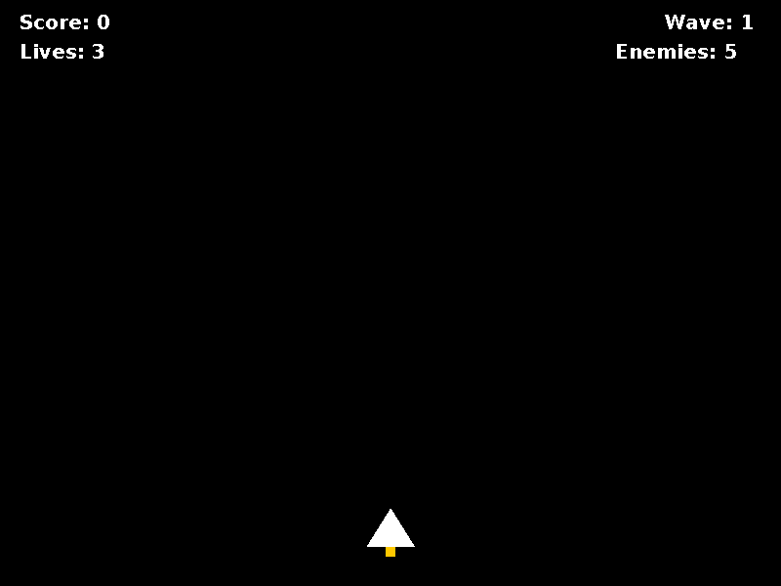
Figure 1 Initial game state
Figures 1 to 3 use the application’s drawing code rendered to an off screen BufferedImage. Figure 2 contains a controlled arrangement of game objects. These illustrations are panel renders rather than screenshots of a manually played desktop session.

4.2 Gameplay and Score
Enemies descend into the playing field from the top. The player moves to align the ship with them and fires upward. A successful hit removes a bullet and an enemy and adds ten points. The current score appears at the upper left; the lives counter appears below it. The upper right shows the wave and the number of enemies still to be handled, including enemies that have not yet appeared.
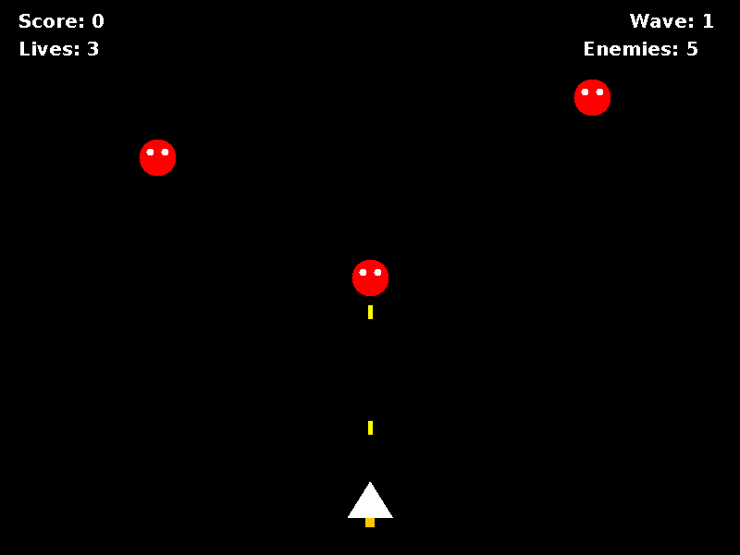
Figure 2 Game objects rendered in a controlled active state
A missed enemy or an enemy that touches the ship reduces lives by one but does not increase score. Both outcomes count toward completion of the wave. After the five enemies of the first wave have been handled and removed, the next wave requires seven. Wave three requires nine, and wave four requires eleven. Speed and spawn interval remain constant; the increase in wave difficulty comes from the growing number of enemies.
For example, destroying all five enemies of the first wave by shooting gives 5 × 10 = 50 points. Shooting four and missing one gives forty points and leaves two lives, provided no other losses occur. These examples follow the scoring rules; they are not measured player performance results.

4.3 Game Over and Restart
When the third life is lost, gameOver is set to true. Subsequent updates skip gameplay logic. The panel displays a dark overlay and the GAME OVER message together with the final score and wave. The R key instruction tells the user how to begin a new session.
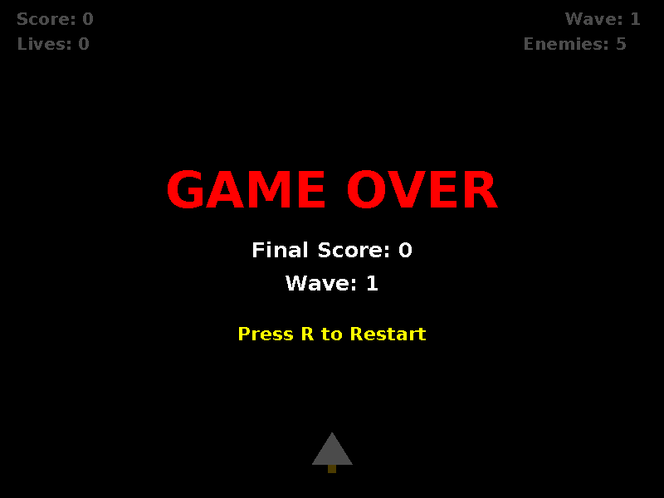
Figure 3 Game over after the lives counter reaches zero
Pressing R in this state constructs a new player at (375, 520), clears the enemy list and restores the initial values. Because bullets belong to Player, replacing that object also clears the bullet collection and input flags. Score becomes zero, lives becomes three, wave becomes one and the required number of enemies becomes five. The existing game thread continues to serve the new session.
Pressing R during normal play does not restart the game. Player receives the event but does not assign an action to that key. There is no pause mode or confirmation dialog in the current interface.

4.4 Validation Results
The five source files were compiled without modification using OpenJDK 17.0.20 and the compiler option --release 17. Compilation completed successfully. With -Xlint:all enabled, the compiler reported one warning: GamePanel inherits serializable behaviour from JPanel but does not declare serialVersionUID. No compilation error was reported.
A separate validation harness executed nineteen focused checks against the compiled classes in headless mode. It used controlled object states and reflective access to private update methods where needed. This allowed movement, spawning, collisions, counters and restart to be evaluated without a graphical desktop. All nineteen checks passed. The harness was kept separate from the project source and is not an application feature.
Test | Scenario and expected result | Result
T01 | Initial state: x 375, y 520, score 0, lives 3, wave 1 and five required enemies | Pass
T02 | One left update changes x from 375 to 369 | Pass
T03 | One right update changes x from 369 to 375 | Pass
T04 | Left movement near the boundary clamps x to 0 | Pass
T05 | Right movement near the boundary clamps x to 750 | Pass
T06 | Space creates one bullet; its first updated position is x 398, y 495 | Pass
T07 | A consumed Space flag does not fire again without another event | Pass
T08 | A bullet becomes inactive after it moves entirely above the panel | Pass
T09 | No spawn at update 59; one enemy at update 60 with x in 0 to 759 | Pass
T10 | Additional spawn attempts do not exceed five enemies in wave one | Pass

The first checks cover initial conditions, input effects and object creation. The remaining checks evaluate interactions and state changes. Exact positions are expressed in panel coordinates, and the spawn interval is expressed in update calls rather than elapsed wall clock time.

Validation results continued
Test | Scenario and expected result | Result
T11 | Bullet hit deactivates both objects, awards 10 points and handles one enemy | Pass
T12 | The following update removes the inactive bullet and enemy | Pass
T13 | Enemy touches player: lives becomes 2, score stays 0 and one enemy is handled | Pass
T14 | Enemy moves past y 600: lose one life, count it and remove it | Pass
T15 | Completing wave one starts wave two with seven enemies and reset counters | Pass
T16 | Repeated life loss stops at 0 and sets gameOver | Pass
T17 | An update after game over leaves the player position unchanged | Pass
T18 | R after game over restores the initial player, statistics and empty lists | Pass
T19 | Interrupting the game thread stops it and preserves its interrupt flag | Pass

These results establish the tested sequential behaviours and interruption response. They do not establish a measured frame rate, prolonged concurrent stability, interactive keyboard focus behaviour or compatibility across multiple operating systems. The original NetBeans Ant build with its configured JDK 26 target was not executed as part of these checks.

4.5 Limitations and Further Development
The principal coursework gap is the missing Stream API use. Collections, lambda predicates and streams are different mechanisms, so the removeIf expressions cannot satisfy that requirement by themselves. A future revision should add a meaningful stream based calculation and include it in the validation plan.
The main technical limitation is shared mutable state between the game thread and the Swing event dispatch thread. Keyboard callbacks write player flags, painting iterates enemy and bullet collections, and game updates mutate those same objects. Restart also changes the player and clears enemies from the input callback. A revision should create the GUI on the event dispatch thread and adopt a consistent state access model, such as a Swing Timer for updates or synchronized snapshots for rendering. [5]
Other possible improvements include a time based firing cooldown, movement scaled by elapsed time, configurable controls and persistent high scores. None of these features is implemented. A further boundary case is worth checking: if the final processed enemy of a wave also costs the final life, the current update can still reach checkWaveComplete and advance the wave before the next update observes gameOver. The final wave display should therefore be defined explicitly in a later revision.

Conclusion
The coursework application implements a two dimensional Space Shooter game using Java, Swing and AWT. Five cooperating classes separate application startup, game coordination, player behaviour, enemy behaviour and projectile behaviour. The program includes keyboard control, geometric rendering, collision detection, score calculation, life management, expanding enemy waves and restart after game over.
The implementation demonstrates practical use of List and ArrayList collections, predicate based cleanup, a dedicated Runnable game loop and handling of InterruptedException. The unchanged source compiled successfully for Java 17, and nineteen focused headless checks passed. The original project remains configured for Java source and target level 26; its NetBeans build and full interactive execution should be checked with the selected development platform.
The result meets the described gameplay behaviours, while the Stream API requirement remains outstanding. Improving access to shared game state and adding a meaningful stream operation are the next steps toward completing all requirements of the course sample. The source listing and UML diagrams document the current implementation rather than those proposed extensions.

List of References
1. Apache Software Foundation. Apache NetBeans official website. https://netbeans.apache.org/front/main/index.html. Accessed 4 October 2026.
2. Oracle. Java SE 26 API documentation. Collection interface. https://docs.oracle.com/en/java/javase/26/docs/api/java.base/java/util/Collection.html. Accessed 4 October 2026.
3. Oracle. Java SE 26 API documentation. Stream interface. https://docs.oracle.com/en/java/javase/26/docs/api/java.base/java/util/stream/Stream.html. Accessed 4 October 2026.
4. Oracle. Java SE 26 API documentation. Thread class. https://docs.oracle.com/en/java/javase/26/docs/api/java.base/java/lang/Thread.html. Accessed 4 October 2026.
5. Oracle. Java SE 26 API documentation. Package javax.swing and Swing threading policy. https://docs.oracle.com/en/java/javase/26/docs/api/java.desktop/javax/swing/package-summary.html. Accessed 4 October 2026.
6. Space Shooter project source archive. Package spaceshooter; SpaceShooter.java, GamePanel.java, Player.java, Enemy.java and Bullet.java; NetBeans project configuration.

Appendix A Program Listing
The following listings contain all five Java source files. Empty lines have been omitted to keep the appendix compact; the code and comments are otherwise retained. The project belongs to the spaceshooter package. The validation harness is separate from the application and is not included in these listings.

A1 SpaceShooter source file
File: src/spaceshooter/SpaceShooter.java
package spaceshooter;
import javax.swing.JFrame;
public class SpaceShooter {
public static void main(String[] args) {
JFrame window = new JFrame("Space Shooter");
window.setDefaultCloseOperation(JFrame.EXIT_ON_CLOSE);
window.setResizable(false);
GamePanel gamePanel = new GamePanel();
window.add(gamePanel);
window.pack();
window.setLocationRelativeTo(null);
window.setVisible(true);
gamePanel.startGame();
}
}

A2 GamePanel source file
File: src/spaceshooter/GamePanel.java
package spaceshooter;
import javax.swing.JPanel;
import java.awt.Color;
import java.awt.Dimension;
import java.awt.Font;
import java.awt.Graphics;
import java.awt.Graphics2D;
import java.awt.Rectangle;
import java.awt.event.KeyEvent;
import java.awt.event.KeyListener;
import java.util.ArrayList;
import java.util.List;
import java.util.Random;
public class GamePanel extends JPanel implements Runnable, KeyListener {
public static final int SCREEN_WIDTH = 800;
public static final int SCREEN_HEIGHT = 600;
private Thread gameThread;
private boolean running;
private Player player;
private List<Enemy> enemies;
private Random random;
private int enemySpawnTimer;
// Game statistics
private int score;
private int lives;
// Wave system
private int wave;
private int enemiesToSpawn;
private int enemiesSpawned;
private int enemiesDefeated;
private boolean waveComplete;
// Game over
private boolean gameOver;
public GamePanel() {
setPreferredSize(
new Dimension(
SCREEN_WIDTH,
SCREEN_HEIGHT
)
);
setBackground(Color.BLACK);
setFocusable(true);
addKeyListener(this);
player = new Player(
SCREEN_WIDTH / 2 - 25,
SCREEN_HEIGHT - 80
);
enemies = new ArrayList<>();
random = new Random();
enemySpawnTimer = 0;
// Initial game values
score = 0;
lives = 3;
wave = 1;
enemiesToSpawn = 5;
enemiesSpawned = 0;
enemiesDefeated = 0;
waveComplete = false;
gameOver = false;
}
public void startGame() {
if (gameThread == null) {
gameThread = new Thread(this);
running = true;
gameThread.start();
}
requestFocusInWindow();
}
@Override
public void run() {
while (running) {
update();
repaint();
try {
Thread.sleep(16);
} catch (InterruptedException ex) {
Thread.currentThread().interrupt();
running = false;
}
}
}
private void update() {
/*
* Stop the game logic when Game Over happens.
*/
if (gameOver) {
return;
}
player.update();
spawnEnemies();
updateEnemies();
checkCollisions();
checkWaveComplete();
}
private void spawnEnemies() {
/*
* Do not spawn more enemies than
* required for the current wave.
*/
if (enemiesSpawned >= enemiesToSpawn) {
return;
}
enemySpawnTimer++;
/*
* Spawn one enemy every 60 frames.
*/
if (enemySpawnTimer >= 60) {
int enemyX =
random.nextInt(
SCREEN_WIDTH - 40
);
enemies.add(
new Enemy(
enemyX,
-40
)
);
enemiesSpawned++;
enemySpawnTimer = 0;
}
}
private void updateEnemies() {
for (Enemy enemy : enemies) {
if (enemy.isActive()) {
enemy.update();
/*
* Enemy reached the bottom.
*
* This costs one life.
*/
if (enemy.reachedBottom()) {
loseLife();
enemiesDefeated++;
}
}
}
/*
* Remove inactive enemies.
*/
enemies.removeIf(
enemy -> !enemy.isActive()
);
}
private void checkCollisions() {
List<Bullet> bullets =
player.getBullets();
/*
* =====================================
* BULLET VS ENEMY
* =====================================
*/
for (Bullet bullet : bullets) {
for (Enemy enemy : enemies) {
if (!bullet.isActive()
|| !enemy.isActive()) {
continue;
}
boolean collision =
bullet.getX()
< enemy.getX()
+ enemy.getWidth()
&& bullet.getX()
+ bullet.getWidth()
> enemy.getX()
&& bullet.getY()
< enemy.getY()
+ enemy.getHeight()
&& bullet.getY()
+ bullet.getHeight()
> enemy.getY();
if (collision) {
/*
* Remove bullet.
*/
bullet.deactivate();
/*
* Remove enemy.
*/
enemy.deactivate();
/*
* Give player points.
*/
score += 10;
/*
* Count defeated enemy.
*/
enemiesDefeated++;
}
}
}
/*
* =====================================
* ENEMY VS PLAYER
* =====================================
*/
Rectangle playerBounds =
new Rectangle(
player.getX(),
player.getY(),
player.getWidth(),
player.getHeight()
);
for (Enemy enemy : enemies) {
if (!enemy.isActive()) {
continue;
}
Rectangle enemyBounds =
new Rectangle(
enemy.getX(),
enemy.getY(),
enemy.getWidth(),
enemy.getHeight()
);
if (playerBounds.intersects(enemyBounds)) {
/*
* Remove enemy.
*/
enemy.deactivate();
/*
* Player loses one life.
*/
loseLife();
/*
* Count this enemy as completed.
*/
enemiesDefeated++;
}
}
}
private void loseLife() {
/*
* Never allow lives to become negative.
*/
if (lives > 0) {
lives--;
/*
* Game Over when lives reach zero.
*/
if (lives == 0) {
gameOver = true;
}
}
}
private void checkWaveComplete() {
/*
* The wave is complete when:
*
* 1. All enemies have been spawned.
* 2. All enemies have been dealt with.
* 3. No active enemies remain.
*/
if (enemiesSpawned >= enemiesToSpawn
&& enemies.isEmpty()
&& enemiesDefeated >= enemiesToSpawn
&& !waveComplete) {
waveComplete = true;
startNextWave();
}
}
private void startNextWave() {
/*
* Increase wave number.
*/
wave++;
/*
* Add two more enemies
* for every new wave.
*
* Wave 1 = 5
* Wave 2 = 7
* Wave 3 = 9
* Wave 4 = 11
*/
enemiesToSpawn =
5 + (wave - 1) * 2;
enemiesSpawned = 0;
enemiesDefeated = 0;
enemySpawnTimer = 0;
waveComplete = false;
}
@Override
protected void paintComponent(Graphics g) {
super.paintComponent(g);
Graphics2D g2 =
(Graphics2D) g;
/*
* Draw player.
*/
player.draw(g2);
/*
* Draw enemies.
*/
for (Enemy enemy : enemies) {
enemy.draw(g2);
}
/*
* Draw HUD.
*/
drawHUD(g2);
/*
* Draw Game Over screen.
*/
if (gameOver) {
drawGameOver(g2);
}
g2.dispose();
}
private void drawHUD(Graphics2D g2) {
g2.setColor(Color.WHITE);
g2.setFont(
new Font(
"Arial",
Font.BOLD,
20
)
);
/*
* Score.
*/
g2.drawString(
"Score: " + score,
20,
30
);
/*
* Lives.
*/
g2.drawString(
"Lives: " + lives,
20,
60
);
/*
* Wave.
*/
g2.drawString(
"Wave: " + wave,
SCREEN_WIDTH - 120,
30
);
/*
* Enemies remaining.
*/
int remaining =
enemiesToSpawn - enemiesDefeated;
if (remaining < 0) {
remaining = 0;
}
g2.drawString(
"Enemies: " + remaining,
SCREEN_WIDTH - 170,
60
);
}
private void drawGameOver(Graphics2D g2) {
/*
* Dark transparent overlay.
*/
g2.setColor(
new Color(
0,
0,
0,
180
)
);
g2.fillRect(
0,
0,
SCREEN_WIDTH,
SCREEN_HEIGHT
);
/*
* GAME OVER text.
*/
g2.setColor(Color.RED);
g2.setFont(
new Font(
"Arial",
Font.BOLD,
60
)
);
String gameOverText =
"GAME OVER";
int textWidth =
g2.getFontMetrics()
.stringWidth(gameOverText);
g2.drawString(
gameOverText,
(SCREEN_WIDTH - textWidth) / 2,
250
);
/*
* Final score.
*/
g2.setColor(Color.WHITE);
g2.setFont(
new Font(
"Arial",
Font.BOLD,
25
)
);
String scoreText =
"Final Score: " + score;
int scoreWidth =
g2.getFontMetrics()
.stringWidth(scoreText);
g2.drawString(
scoreText,
(SCREEN_WIDTH - scoreWidth) / 2,
310
);
/*
* Final wave.
*/
String waveText =
"Wave: " + wave;
int waveWidth =
g2.getFontMetrics()
.stringWidth(waveText);
g2.drawString(
waveText,
(SCREEN_WIDTH - waveWidth) / 2,
350
);
/*
* Restart instruction.
*/
g2.setColor(Color.YELLOW);
g2.setFont(
new Font(
"Arial",
Font.BOLD,
22
)
);
String restartText =
"Press R to Restart";
int restartWidth =
g2.getFontMetrics()
.stringWidth(restartText);
g2.drawString(
restartText,
(SCREEN_WIDTH - restartWidth) / 2,
410
);
}
private void restartGame() {
/*
* Create a new player.
*/
player = new Player(
SCREEN_WIDTH / 2 - 25,
SCREEN_HEIGHT - 80
);
/*
* Remove all enemies.
*/
enemies.clear();
/*
* Reset score.
*/
score = 0;
/*
* Reset lives.
*/
lives = 3;
/*
* Reset wave.
*/
wave = 1;
/*
* Reset enemies per wave.
*/
enemiesToSpawn = 5;
enemiesSpawned = 0;
enemiesDefeated = 0;
/*
* Reset spawn timer.
*/
enemySpawnTimer = 0;
/*
* Reset game states.
*/
waveComplete = false;
gameOver = false;
/*
* Return keyboard focus.
*/
requestFocusInWindow();
}
@Override
public void keyPressed(KeyEvent e) {
/*
* Restart after Game Over.
*/
if (gameOver
&& e.getKeyCode() == KeyEvent.VK_R) {
restartGame();
return;
}
/*
* Normal player controls.
*/
player.keyPressed(e);
}
@Override
public void keyReleased(KeyEvent e) {
player.keyReleased(e);
}
@Override
public void keyTyped(KeyEvent e) {
// Not used
}
}

A3 Player source file
File: src/spaceshooter/Player.java
package spaceshooter;
import java.awt.Color;
import java.awt.Graphics2D;
import java.awt.event.KeyEvent;
import java.util.ArrayList;
import java.util.List;
public class Player {
private int x;
private int y;
private final int width = 50;
private final int height = 40;
private final int speed = 6;
private boolean leftPressed;
private boolean rightPressed;
private boolean spacePressed;
private final List<Bullet> bullets;
public Player(int x, int y) {
this.x = x;
this.y = y;
bullets = new ArrayList<>();
}
public void update() {
if (leftPressed) {
x -= speed;
}
if (rightPressed) {
x += speed;
}
if (x < 0) {
x = 0;
}
if (x + width > GamePanel.SCREEN_WIDTH) {
x = GamePanel.SCREEN_WIDTH - width;
}
if (spacePressed) {
shoot();
spacePressed = false;
}
for (Bullet bullet : bullets) {
bullet.update();
}
bullets.removeIf(bullet -> !bullet.isActive());
}
private void shoot() {
int bulletX = x + width / 2 - 2;
int bulletY = y - 15;
bullets.add(
new Bullet(bulletX, bulletY)
);
}
public void draw(Graphics2D g2) {
// Ship body
g2.setColor(Color.WHITE);
int[] xPoints = {
x + width / 2,
x,
x + width
};
int[] yPoints = {
y,
y + height,
y + height
};
g2.fillPolygon(
xPoints,
yPoints,
3
);
// Engine
g2.setColor(Color.ORANGE);
g2.fillRect(
x + width / 2 - 5,
y + height,
10,
10
);
// Bullets
for (Bullet bullet : bullets) {
bullet.draw(g2);
}
}
public void keyPressed(KeyEvent e) {
if (e.getKeyCode() == KeyEvent.VK_LEFT) {
leftPressed = true;
}
if (e.getKeyCode() == KeyEvent.VK_RIGHT) {
rightPressed = true;
}
if (e.getKeyCode() == KeyEvent.VK_SPACE) {
spacePressed = true;
}
}
public void keyReleased(KeyEvent e) {
if (e.getKeyCode() == KeyEvent.VK_LEFT) {
leftPressed = false;
}
if (e.getKeyCode() == KeyEvent.VK_RIGHT) {
rightPressed = false;
}
}
public List<Bullet> getBullets() {
return bullets;
}
public int getX() {
return x;
}
public int getY() {
return y;
}
public int getWidth() {
return width;
}
public int getHeight() {
return height;
}
}

A4 Enemy source file
File: src/spaceshooter/Enemy.java
package spaceshooter;
import java.awt.Color;
import java.awt.Graphics2D;
public class Enemy {
private int x;
private int y;
private final int width = 40;
private final int height = 40;
private final int speed = 3;
private boolean active;
private boolean reachedBottom;
public Enemy(int x, int y) {
this.x = x;
this.y = y;
active = true;
reachedBottom = false;
}
public void update() {
y += speed;
if (y > GamePanel.SCREEN_HEIGHT) {
active = false;
reachedBottom = true;
}
}
public void draw(Graphics2D g2) {
g2.setColor(Color.RED);
g2.fillOval(
x,
y,
width,
height
);
// Enemy eyes
g2.setColor(Color.WHITE);
g2.fillOval(
x + 8,
y + 10,
8,
8
);
g2.fillOval(
x + 24,
y + 10,
8,
8
);
}
public boolean isActive() {
return active;
}
public boolean reachedBottom() {
return reachedBottom;
}
public void deactivate() {
active = false;
reachedBottom = false;
}
public int getX() {
return x;
}
public int getY() {
return y;
}
public int getWidth() {
return width;
}
public int getHeight() {
return height;
}
}

A5 Bullet source file
File: src/spaceshooter/Bullet.java
package spaceshooter;
import java.awt.Color;
import java.awt.Graphics2D;
public class Bullet {
private int x;
private int y;
private final int width = 5;
private final int height = 15;
private final int speed = 10;
private boolean active;
public Bullet(int x, int y) {
this.x = x;
this.y = y;
this.active = true;
}
public void update() {
y -= speed;
if (y + height < 0) {
active = false;
}
}
public void draw(Graphics2D g2) {
g2.setColor(Color.YELLOW);
g2.fillRect(
x,
y,
width,
height
);
}
public boolean isActive() {
return active;
}
public int getX() {
return x;
}
public int getY() {
return y;
}
public int getWidth() {
return width;
}
public int getHeight() {
return height;
}
public void deactivate() {
active = false;
}
}

Appendix B UML Diagrams

B1 UML Use Case Diagram
The only external actor is the player. The use cases describe the available actions and the information the player observes. Restart is available after game over. Closing the window terminates the local application.
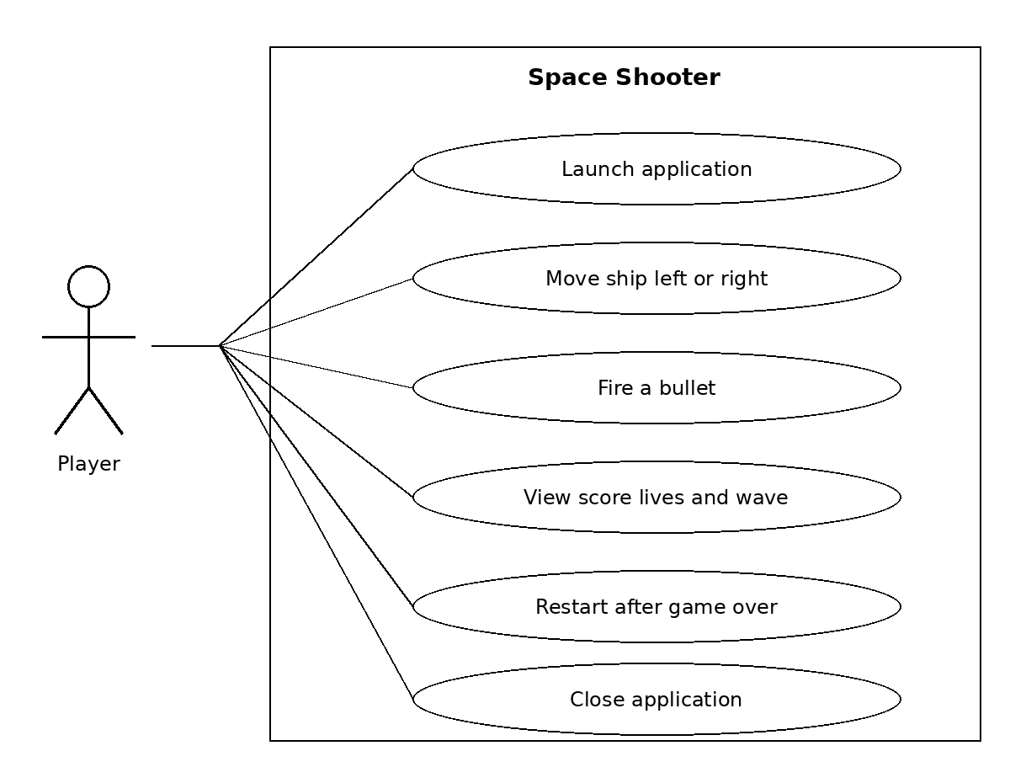
Figure B1 Player interactions with Space Shooter

B2 UML Class Diagram
The diagram shows the five application classes and selected members, together with the Swing superclass and implemented interfaces. Filled diamonds show ownership of player, enemy and bullet objects. SpaceShooter creates GamePanel during startup. Methods and attributes are selected to keep the diagram readable.
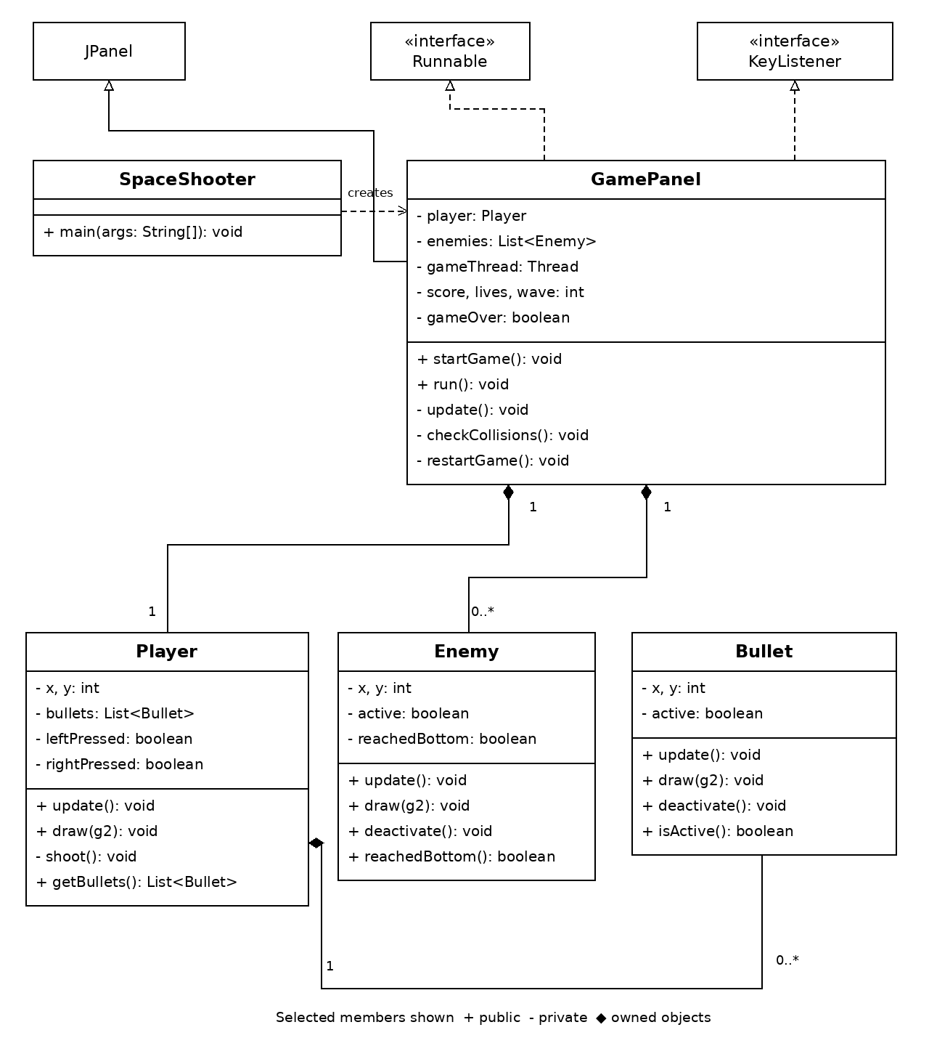
Figure B2 Application classes and their principal relationships
GamePanel owns one current Player and zero or more enemies. Player owns zero or more bullets. GamePanel also reads the player’s bullets through getBullets during collision checks. The source listing provides the complete set of members.

B3 UML Activity Diagram
The activity models one call to GamePanel.update. An existing game over state returns immediately. Otherwise player updates, spawning, enemy movement and collision checks are followed by the wave completion check. The waveComplete guard prevents repeated transition for the same completed wave.
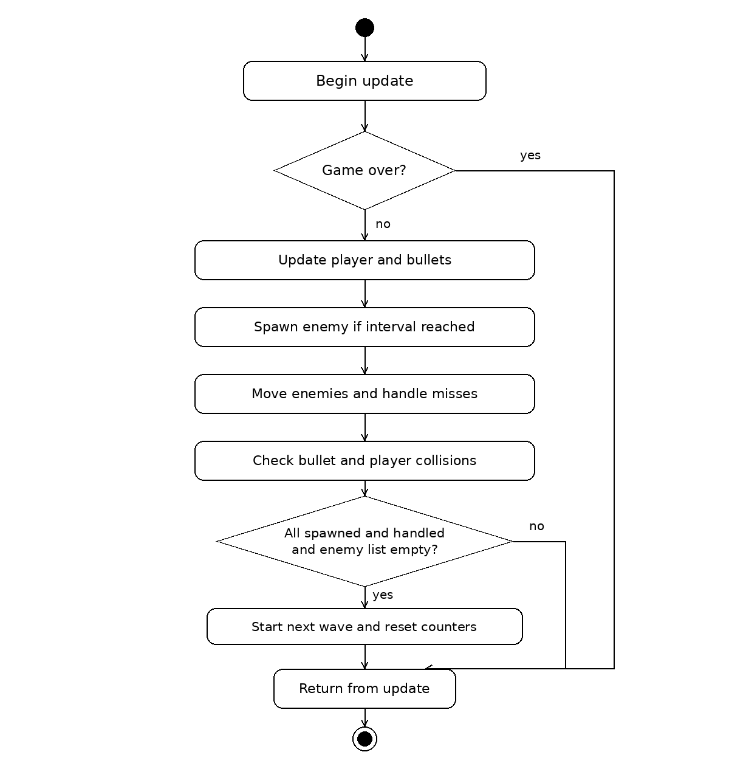
Figure B3 One simulation update and the wave transition

B4 UML Sequence Diagram
This interaction shows the principal calls during an update that includes a successful bullet hit. The Bullet and Enemy lifelines are grouped to simplify repeated position, movement and deactivation operations. The hit branch awards ten points and increments the handled enemy counter.
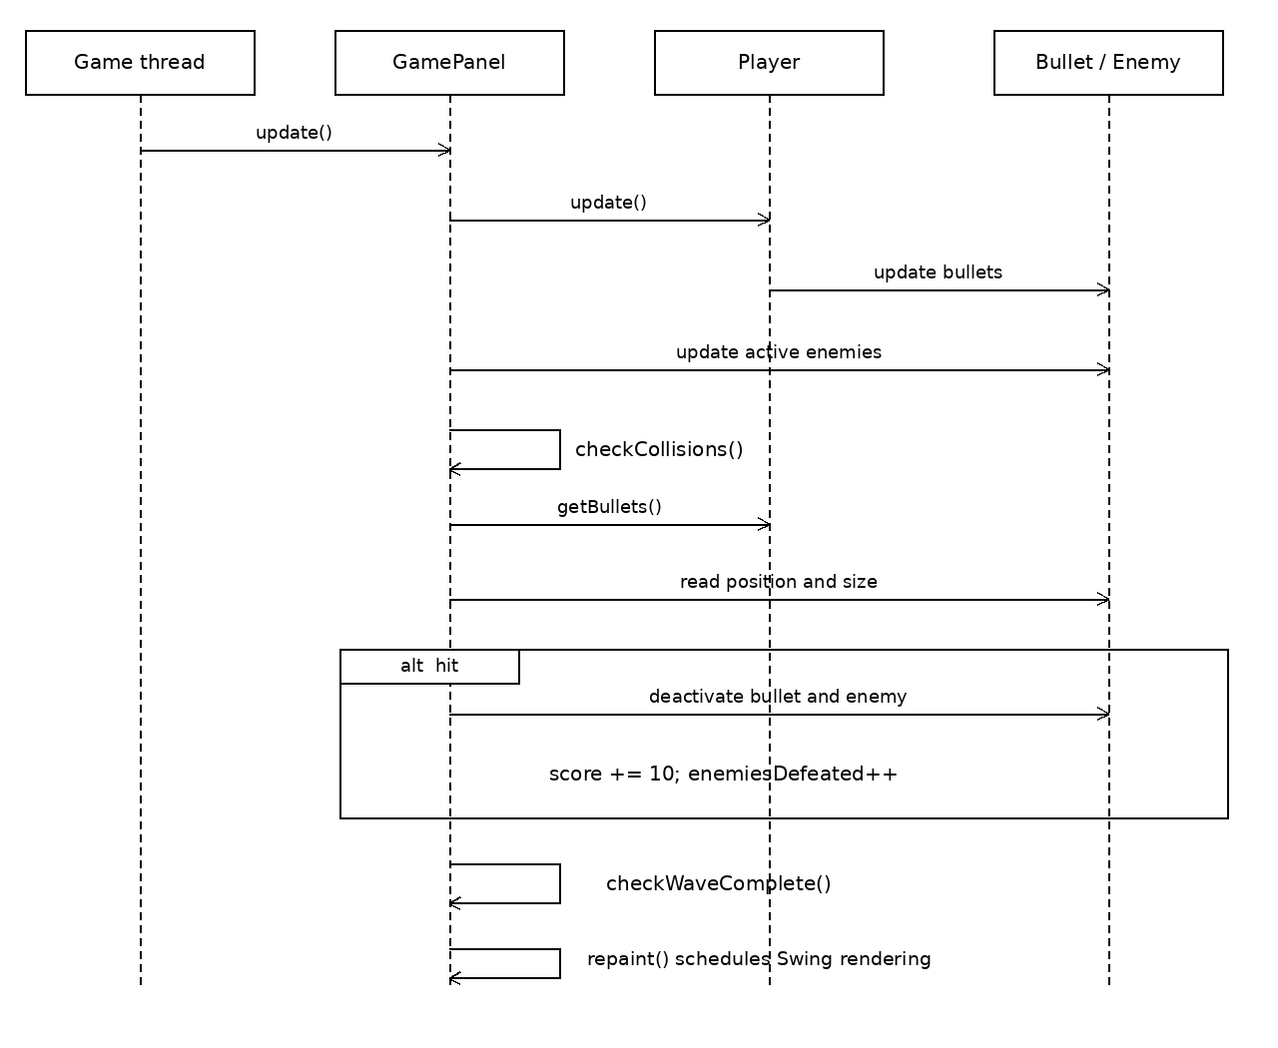
Figure B4 Object interaction during a successful hit
repaint requests a later Swing paint operation; it does not immediately execute paintComponent on the game thread. Enemy spawning and input events are omitted from this selected sequence because they are not needed to explain the collision interaction.

B5 UML Deployment Diagram
The application is deployed on one desktop computer and runs within the Java Virtual Machine. The diagram shows the intended distribution artifact SpaceShooter.jar configured by the NetBeans project and the standard Java modules it uses. No remote component is required.
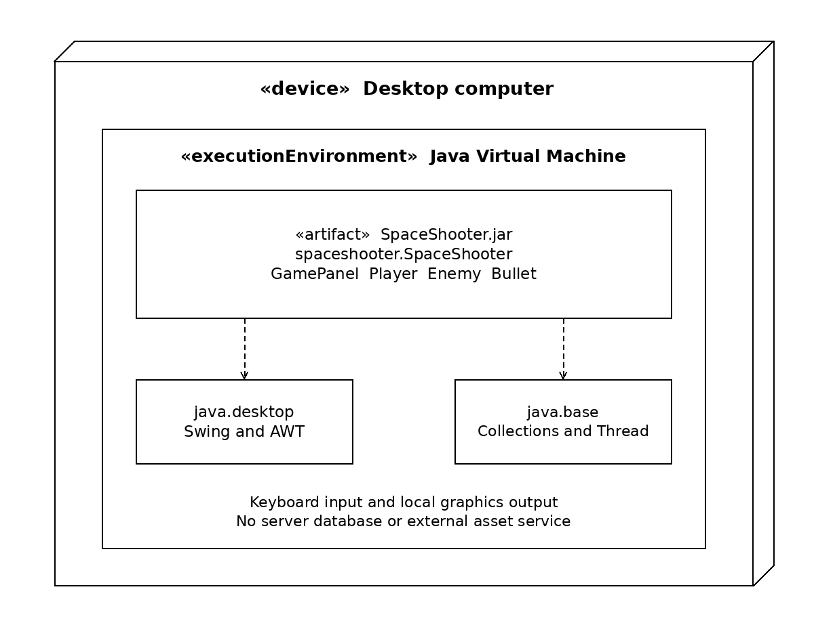
Figure B5 Local desktop deployment of the Java game
java.desktop supplies Swing and AWT; java.base supplies collections, random number generation and thread support. A graphical desktop and keyboard are needed for normal interaction. The source compilation and headless checks in Section 4.4 used a separate verification class directory rather than a packaged release JAR.

